

Air University Aerospace and Aviation campus Kamra

Submitted by:
Muhammad Shahram Tariq
Submitted to:
Ms. Rubab
Registration No:
245320
Department:
SOFTWARE ENGINEERING
Subject:
OOP(Lab)
Date:5 /may/2025
LAB TASK NO : 08

QUESTION NO :01
CODE:
import java.util.*;
public class Main {
public static void main(String[] args) {
Scanner nsc=new Scanner(System.in);
System.out.println("Enter the first number: ");
int num1 =nsc.nextInt();
System.out.println("ENter the second number: ");
int num2=nsc.nextInt();
System.out.println("do you want to add them or subtract them: ");
System.out.println("For addition enter 1 :For subtraction enter 2 ");
int num3=nsc.nextInt();
switch (num3){
case 1:
System.out.println("Output: "+(num1+num2));
break;
case 2:
System.out.println("Output: "+(num1-num2));
break;
default:
System.out.println("Invalid input!. try again");
break;
}
}
}

OUTPUT:
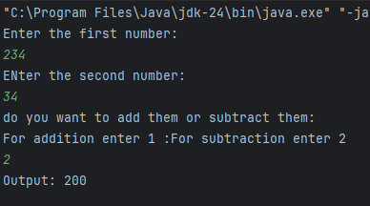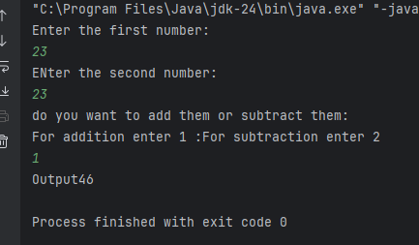

QUESTION NO :02
CODE:
import java.util.*;
public class Main {
public static void main(String[] args) {
char xr;
do{
Scanner nsc=new Scanner(System.in);
System.out.println("Enter the first number: ");
double num1 =nsc.nextInt();
System.out.println("ENter the second number: ");
double num2=nsc.nextInt();
System.out.println("do you want to multiply them or divide them: ");
System.out.println("For Multiplication enter 1 :For Division enter 2 ");
int num3=nsc.nextInt();
switch (num3) {
case 1:
System.out.println("Output: " + (num1 * num2));
break;
case 2:
System.out.println("Output: " + (num1 / num2));
break;
default:
System.out.println("Invalid input!. try again");
break;
}
System.out.println("Do you want you run again: ");
xr= nsc.next().charAt(0);
}while(xr=='y'||xr=='Y');
}
}

OUTPUT:
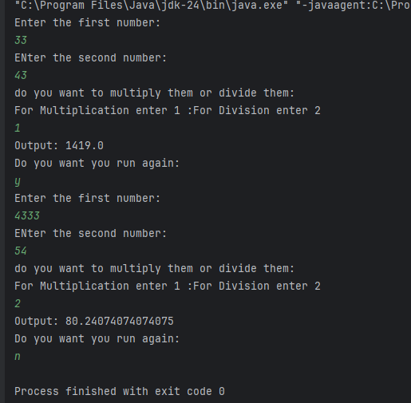

QUESTION NO :03
CODE:
import java.util.*;
class Student{
String name;
int age;
Student(String na, int ag)
{
name=na;
age=ag;
}
void display()
{
System.out.println("Student Name: "+name);
System.out.println("Student Age: "+age);
}
}
public class Main {
public static void main(String[] args) {
Scanner nsc=new Scanner(System.in);
System.out.println("Enter your name: ");
String n =nsc.nextLine();
System.out.println("Enter your age:: ");
int num2=nsc.nextInt();
Student std=new Student(n,num2);
std.display();
}
}
OUTPUT:
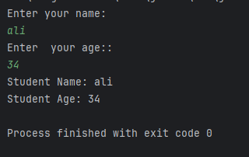

QUESTION NO :04
CODE:
import java.awt.*;
import java.awt.event.*;
public class AwtButtonExample {
AwtButtonExample() {
Frame f = new Frame("AWT GUI EXAMPLE");
f.setLayout(new BorderLayout());
Panel buttonPanel = new Panel(new GridLayout(2, 5));
Label notificationLabel = new Label("Press a button...", Label.CENTER);
for (int i = 0; i < 10; i++) {
final int buttonNumber = i;
Button b = new Button("Button: " + i);
b.addActionListener(new ActionListener() {
public void actionPerformed(ActionEvent e) {
notificationLabel.setText("You pressed Button: " + buttonNumber);
}
});
buttonPanel.add(b);
}
f.add(buttonPanel, BorderLayout.CENTER);
f.add(notificationLabel, BorderLayout.SOUTH);
f.setSize(400, 150);
f.setVisible(true);
f.addWindowListener(new WindowAdapter() {
public void windowClosing(WindowEvent e) {
f.dispose();
}
}
);
}
public static void main(String[] args) {
new AwtButtonExample();
}
}

OUTPUT:
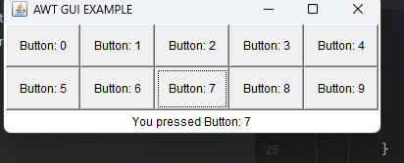

QUESTION NO :05
CODE:
import javax.swing.*;
import java.awt.*;
import java.awt.event.*;
public class Main {
public static void main(String[] args) {
// Create the frame
JFrame frame = new JFrame("Salam habbi");
frame.setSize(300, 150);
frame.setDefaultCloseOperation(JFrame.EXIT_ON_CLOSE);
frame.setLayout(new FlowLayout());
JLabel label = new JLabel("Enter Name:");
JTextField textField = new JTextField(15);
JButton button = new JButton("Submit");
button.addActionListener(new ActionListener() {
public void actionPerformed(ActionEvent e) {
String name = textField.getText();
JOptionPane.showMessageDialog(frame, " السلام عليكم " + name);
}
});
frame.add(label);
frame.add(textField);
frame.add(button);
frame.setVisible(true);
}
}

OUTPUT:
